Name of the Student: G. Manasa | Academic Year: 2025-26
Student Registration Number: 241U1R3007 | Year & Term: II & I
Study Level: UG | Class & Section: CSE(DS)-2A
Name of the Course: Startup Management | Name of the Instructor: Meghna Bandi mam
Name of the Assessment: Practice Assignment 2 | Date of Submission: 07-09-2025

Practice Assignment 2

6. Financial Planning Tool venture of MVSR DIRECT FRESH MILK
7. Team members
8. Social Media
9.Webpage

Practice Session 6: financial tool of ignite

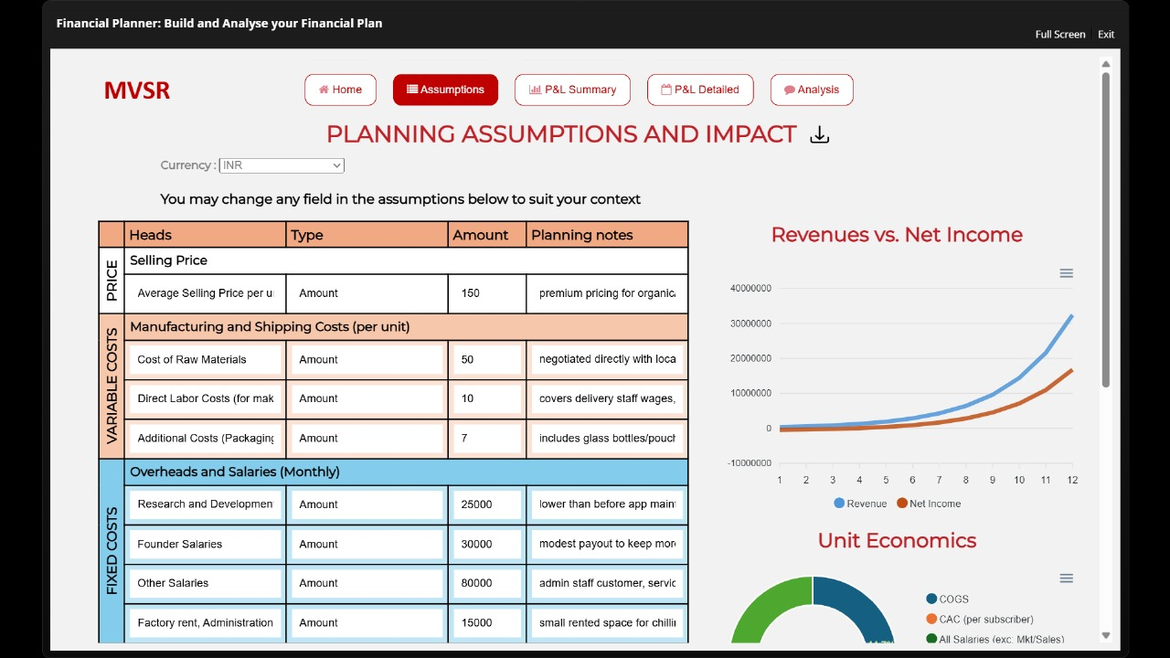

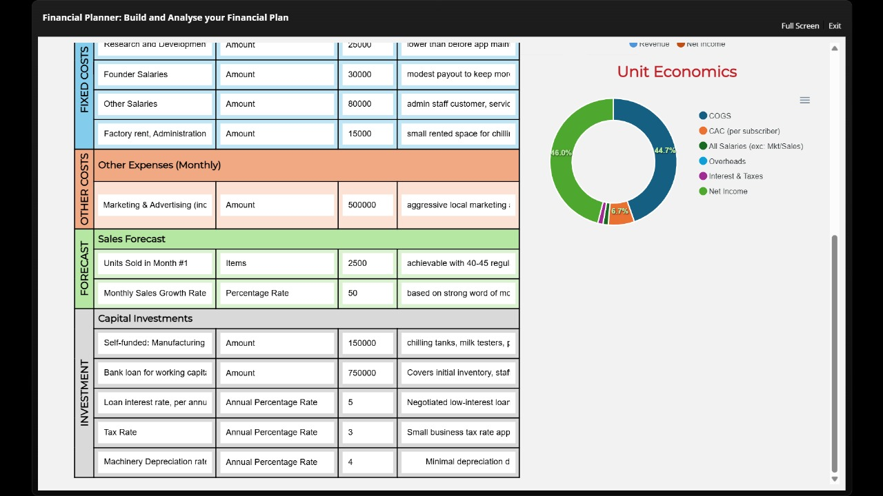

My Learnings:
I learned that the financial tool of Ignite helped me understand how money is planned and managed in our venture MVSR Direct Fresh Milk. I understood how the selling price of ₹150 was fixed by looking at the cost of raw materials, labor, and packaging. I also came to know that fixed costs like salaries, rent, and research need to be managed every month. Another important learning was that marketing takes a big amount but it is necessary to reach more customers and grow sales. From the sales forecast, I learned how to plan for targets, like starting with 2,500 units in the first month and then expecting 50% growth every month. I also saw how investment and loans play a big role in running the business and how we must think about interest, tax, and depreciation. Looking at the revenue and net income graph, I understood that in the beginning expenses are high, so profits are less, but slowly as sales increase, profits also grow. The unit economics helped me see clearly where the money is spent and how much is left as net income. Overall, this gave me a good understanding of how financial planning is the backbone of a venture.

Practice Session 7: Team members for MVSR
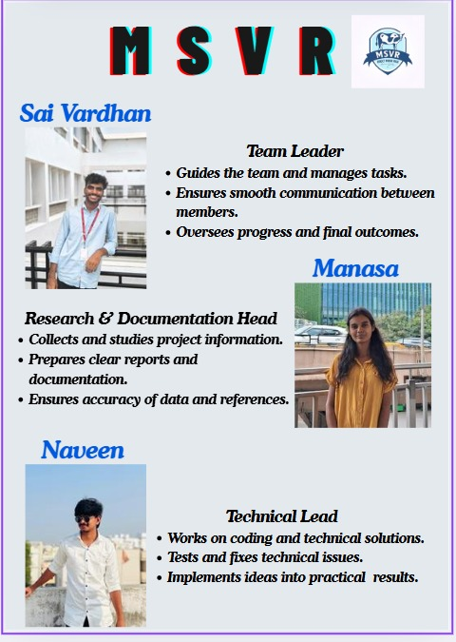
My Learnings:
I learned that creating our team company profile for MVSR Direct Fresh Milk helped me understand how important teamwork is in building a venture. Each member has a role like team leader, research & documentation head, and technical lead and all roles are connected to make the project successful. By preparing this profile, I realized how clear responsibilities and communication make work easier and organized. It also gave me confidence that when we combine our skills, we can handle challenges better and achieve good results.

Practice Session 8: Social Media on MVSR DIECT FRESH MILK
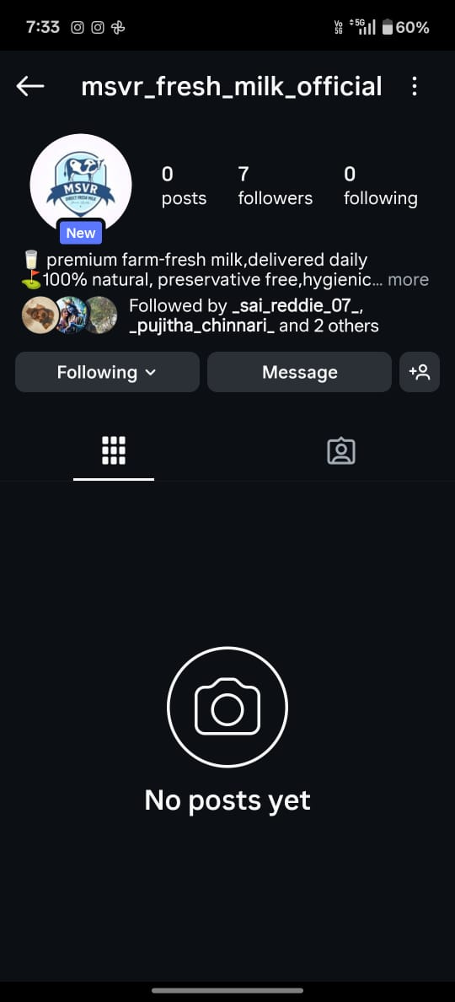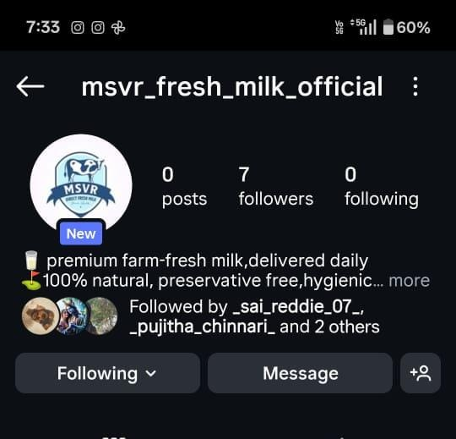

My Learnings:
We created an Instagram page for MVSR Fresh Milk Official, and it was a good experience because I learned how to show our product online and connect with people. By using Instagram, we can post pictures, reels, and stories to highlight the freshness and quality of our milk. I understood that social media helps to make a brand more visible, attract more customers, and build trust in an easy way.

Practice Session 9: Webpage
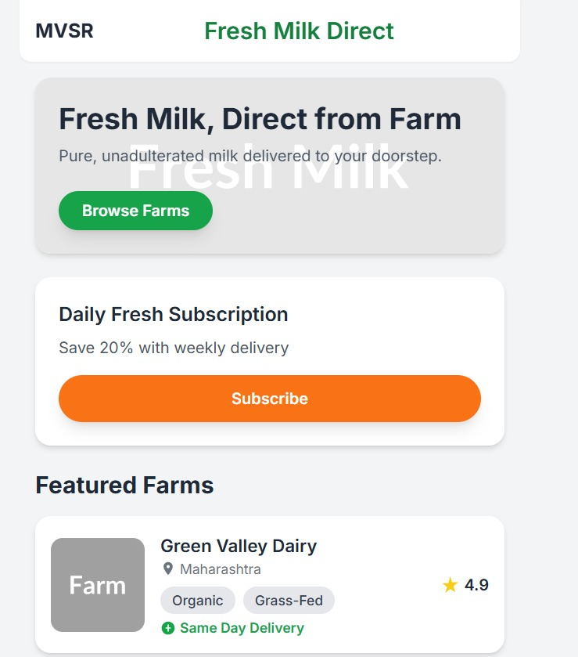
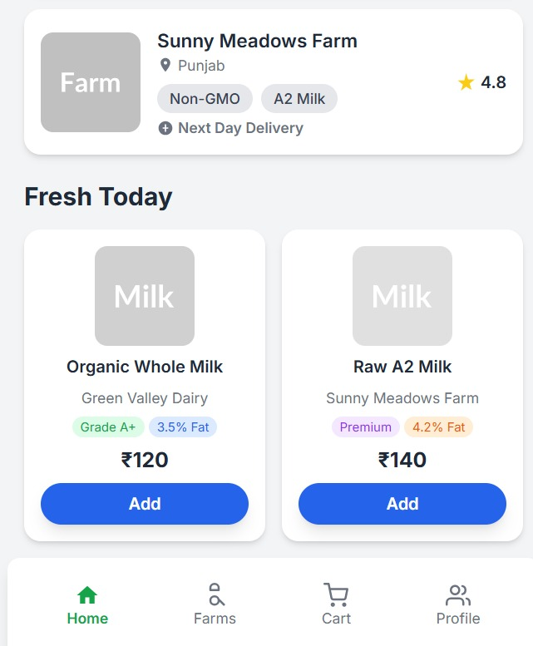
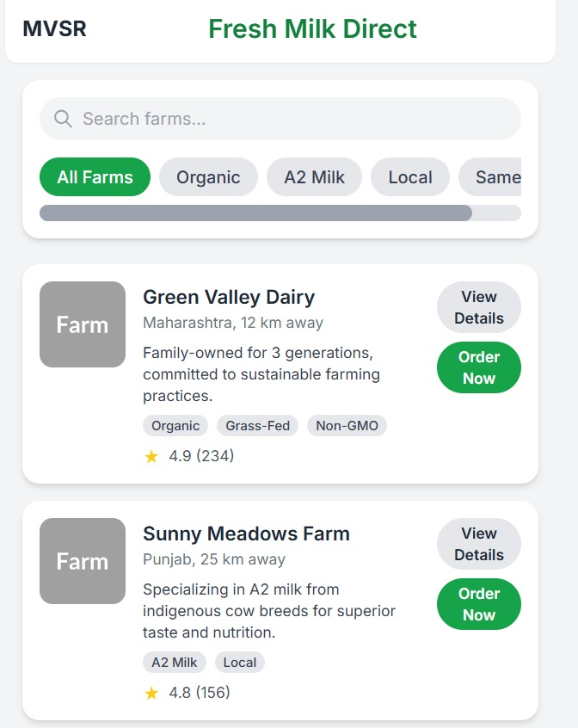
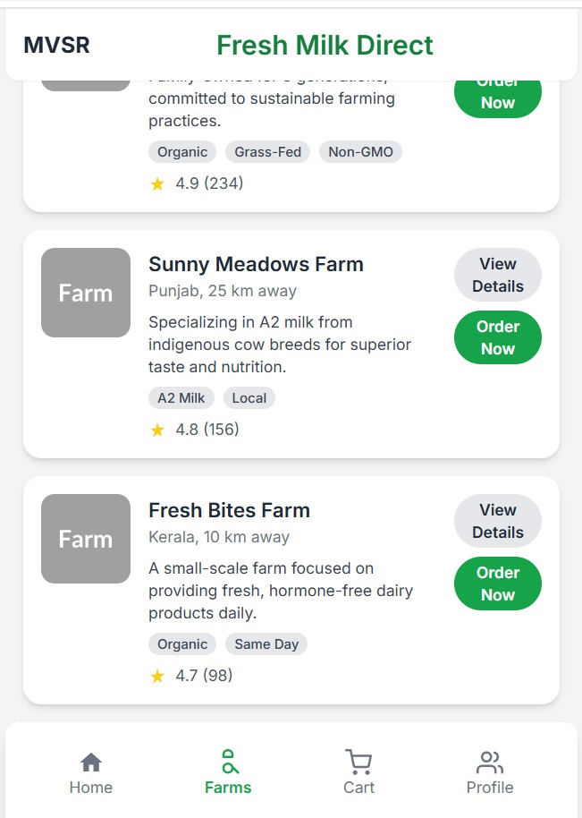
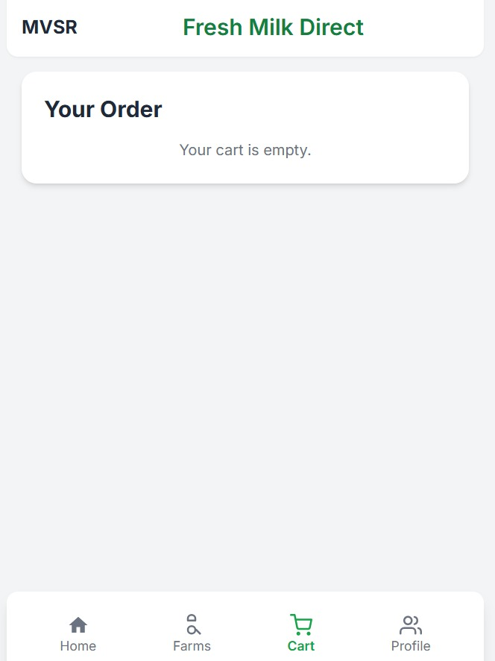
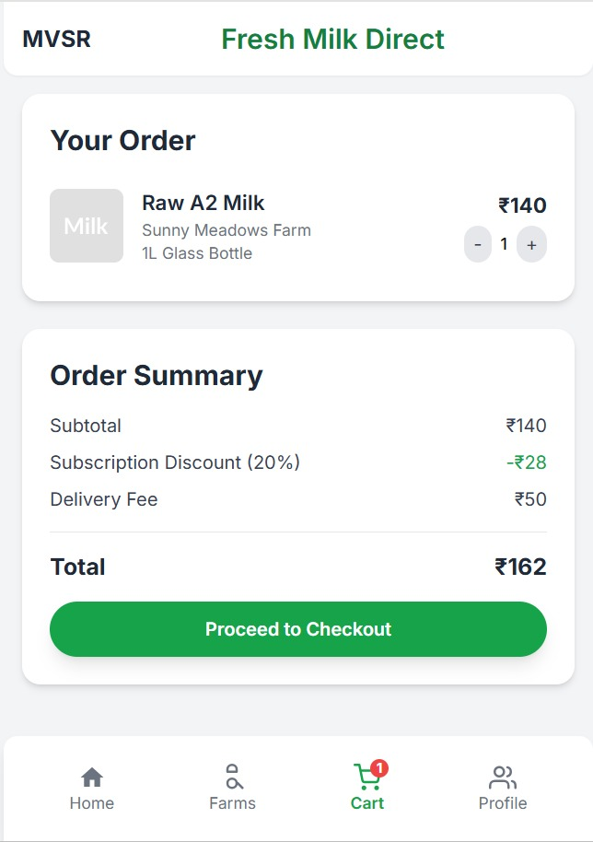
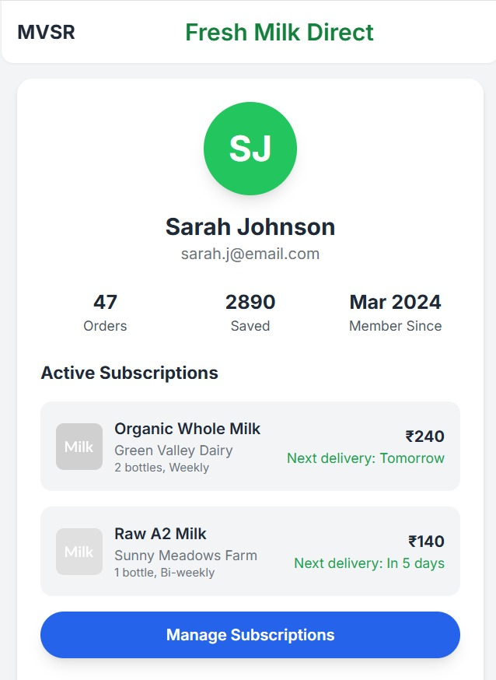
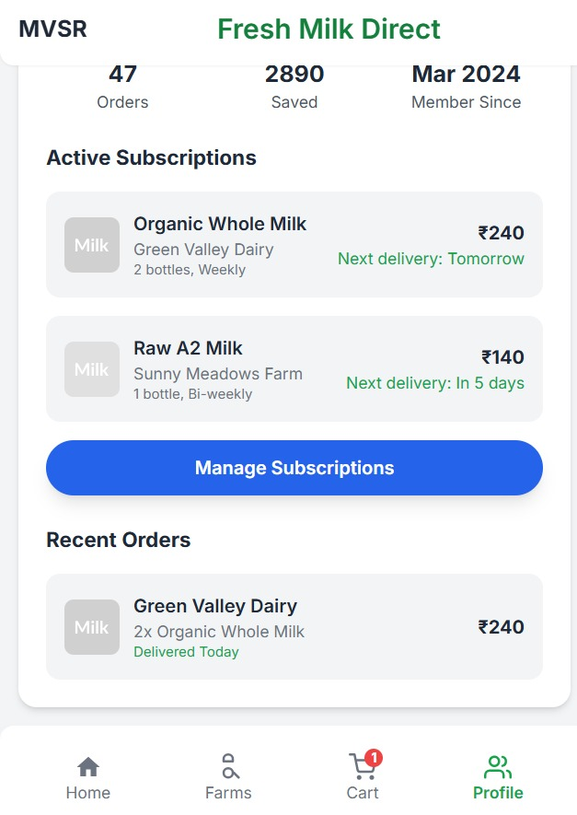
My Learnings:
A key learning from this experience is that even with just a simple platform like an Instagram page or a basic website, it is possible to create a professional look for a business idea. By showing features such as fresh farm-to-home milk delivery, daily subscriptions, organic and A2 milk options, pricing, and ratings, we learned how to present our product in a clear and attractive way to customers.
This also taught us how important it is to highlight trust factors like "organic," "grass-fed," "non-GMO," and delivery options, because these details make customers feel confident in choosing the product. Most importantly, we realized that presenting products in an organized way with options, prices, and subscription models helps customers understand and connect with the service better.

